Data Extraction Instructions – Fax
Extract:
- Date: 25/12/2012
- Doc # (Telecopie #): 71702077
- To/Recipient (À): Service Recouvrement
- From/Sender (De): Abderrahmen Abdelli
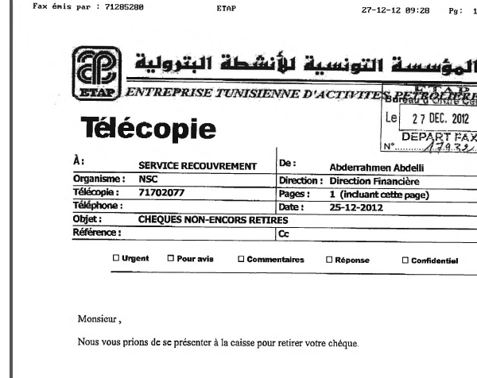

- Date: 16/10/2006
- Doc # (Telecopie #): 0021671702077

